Problem Set 1: Simulation of Fetch/Execute
Cycle for a Hypothetical Machine
CSci 430 Introduction to Operating Systems

Assigned:
Unit 01: Operating System Concepts

Submitting:
I have provided a word .doc versions of the file. My preferred method of you submitting this assignment is to simply fill out the missing values in the tables below, save the file, and submit through the MyLeoOnline submission folder for this assignment. A PDF or scan of handwritten work is fine as well, though make sure all handwritten work is neat and legible.

The following hypothetical machine is from Chapter 1 of our textbook:

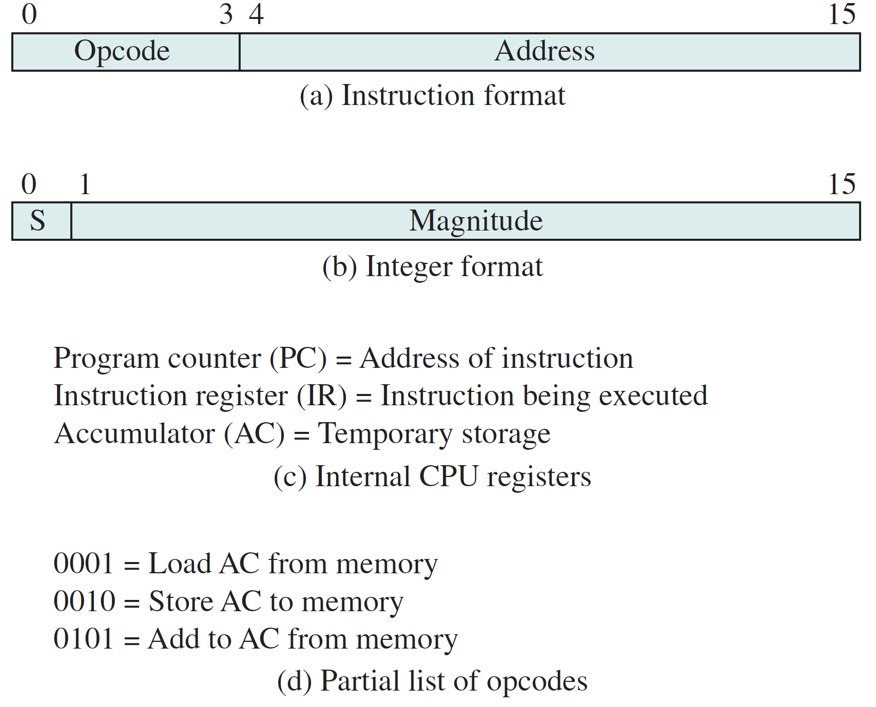
In the following problem sets, we will use this expanded set of opcodes for our hypothetical machine:

0001 = Load AC from memory (LOAD)
0010 = Store AC to memory (STOR)
0011 = Multiply AC times memory (result in AC) (MUL)
0100 = Subtract memory from AC (result in AC) (SUB)
0101 = Add to AC from memory (result in AC) (ADD)
0110 = Jump to address, absolute jump (JMP)
0111 = Jump to address if result was 0, conditional jump (JMPZ)
1000 = Jump to address if result was negative, conditional jump (JMPN)

Perform program fetch/execute cycles for the following initial memory and program states. Here are some notes/hints and clarifications for how to perform these hypothetical machine simulations by hand:

- When executing the machine instructions, if the PC ends up fetching a memory address that you were not given values for, then you are done. This means that for some of the questions you may only fill in the first 6 of the 8 cells. But for others, like if there is an infinite loop, if you fill up all 8 cells you don't have to do any more work, you are done at that point.
- It is possible for one or more of the questions to end up with a negative number as your result in the accumulator. If you read our textbook, and look at the figure 1.3, there is a definition for our hypothetical machine of how integers are to be represented. This integer representation uses a simple sign bit for the most significant bit, and the sign bit should be 1 to indicate a negative integer number. If you get a negative number in your AC, make sure you correctly represent it using the defined sign/magnitude integer representation format for our hypothetical machine. It should be displayed as a hexadecimal number in the answer you give for the problem set.
- All values given in the memory and registers for the problem are hexadecimal (base 16), that represent 16 bits of information. You should represent all results as hexadecimal values as well, including signed integers. So for example, you should not give me -1 if your result is negative 1, but the signed integer representation of this value according to our hypothetical machine, 0x8001
- The jump if zero instruction performs a conditional jump depending on if the previous result (the value in the accumulator) was zero or nonzero. Only jump to the indicated address if the result was 0. Likewise the jump if negative instruction depends on the previous accumulator result, and the jump should occur only if the previous accumulator result was a negative number.

Problem 1

Fetch stage | Execute stage
Fetch 1 | Execute 1
   | Memory | CPU registers
  0009 | 4AFF | 0009 | PC
  000A | 5B00 | 0002 | AC
  000B | 2AFF | 4AFF | IR
   | . . .
  0AFF | 0005
  0B00 | 8007
   | Memory | CPU registers
  0009 | 4AFF | 000A | PC
  000A | 5B00 | 8003 | AC
  000B | 2AFF | 4AFF | IR
   | . . . | SUB 2-5=-3
  0AFF | 0005
  0B00 | 8007
Fetch 2 | Execute 2
   | Memory | CPU registers
  0009 | 4AFF | 000A | PC
  000A | 5B00 | 8003 | AC
  000B | 2AFF | 5B00 | IR
   | . . .
  0AFF | 0005
  0B00 | 8007
   | Memory | CPU registers
  0009 | 4AFF | 000B | PC
  000A | 5B00 | 8005 | AC
  000B | 2AFF | 5B00 | IR
   | . . . | ADD -3+-2=-5
  0AFF | 0005
  0B00 | 8007
Fetch 3 | Execute 3
   | Memory | CPU registers
  0009 | 4AFF | 000B | PC
  000A | 5B00 | 8005 | AC
  000B | 2AFF | 2AFF | IR
   | . . .
  0AFF | 0005
  0B00 | 8007
   | Memory | CPU registers
  0009 | 4AFF | 000C | PC
  000A | 5B00 | 0005 | AC
  000B | 2AFF | 2AFF | IR
   | . . . | STOR 0005
  0AFF | 0005
  0B00 | 8007
Fetch 4 | Execute 4
   | Memory | CPU registers
  0009 | 4AFF | 000C | PC
  000A | 5B00 | 0005 | AC
  000B | 2AFF |  | IR
   | . . . | HALT
  0AFF | 0005
  0B00 | 8007
   | Memory | CPU registers
  0009 | 4AFF |  | PC
  000A | 5B00 |  | AC
  000B | 2AFF |  | IR
   | . . .
  0AFF | 0005
  0B00 | 8007

Problem 2

Fetch stage | Execute stage
Fetch 1 | Execute 1
   | Memory | CPU registers
  085F | 5B00 | 085F | PC
  0860 | 785F | 0002 | AC
  0861 | 2AFF | 5B00 | IR
   | . . .
  0AFF | 0005
  0B00 | 8002
   | Memory | CPU registers
  085F | 5B00 | 0860 | PC
  0860 | 785F | 0 | AC
  0861 | 2AFF | 5B00 | IR
   | . . . | ADD 2+(-2) =0
  0AFF | 0005
  0B00 | 8002
Fetch 2 | Execute 2
   | Memory | CPU registers
  085F | 5B00 | 0860 | PC
  0860 | 785F | 0 | AC
  0861 | 2AFF | 785F | IR
   | . . .
  0AFF | 0005
  0B00 | 8002
   | Memory | CPU registers
  085F | 5B00 | 085F | PC
  0860 | 785F | 0 | AC
  0861 | 2AFF | 785F | IR
   | . . . | JMPZ True
  0AFF | 0005
  0B00 | 8002
Fetch 3 | Execute 3
   | Memory | CPU registers
  085F | 5B00 | 085F | PC
  0860 | 785F | 0 | AC
  0861 | 2AFF | 5B00 | IR
   | . . .
  0AFF | 0005
  0B00 | 8002
   | Memory | CPU registers
  085F | 5B00 | 0860 | PC
  0860 | 785F | 8002 | AC
  0861 | 2AFF | 5B00 | IR
   | . . . | ADD 0+(-2) =-2
  0AFF | 0005
  0B00 | 8002
Fetch 4 | Execute 4
   | Memory | CPU registers
  085F | 5B00 | 0860 | PC
  0860 | 785F | 8002 | AC
  0861 | 2AFF | 785F | IR
   | . . .
  0AFF | 0005
  0B00 | 8002
   | Memory | CPU registers
  085F | 5B00 | 0861 | PC
  0860 | 785F | 8002 | AC
  0861 | 2AFF | 785F | IR
   | . . . | JMPZ False
  0AFF | 0005
  0B00 | 8002

Problem 3

Fetch stage | Execute stage
Fetch 1 | Execute 1
   | Memory | CPU registers
  085F | 4CEE | 085F | PC
  0860 | 7862 | 0002 | AC
  0861 | 685F | 4CEE | IR
   | . . .
  0CEE | 0001
  0CEF | 8002
   | Memory | CPU registers
  085F | 4CEE | 0860 | PC
  0860 | 7862 | 0001 (Hex) | AC
  0861 | 685F | 4CEE | IR
   | . . . | SUB 2-1=1
  0CEE | 0001
  0CEF | 8002
Fetch 2 | Execute 2
   | Memory | CPU registers
  085F | 4CEE | 0860 | PC
  0860 | 7862 | 0001 | AC
  0861 | 685F | 7862 | IR
   | . . .
  0CEE | 0001
  0CEF | 8002
   | Memory | CPU registers
  085F | 4CEE | 0861 | PC
  0860 | 7862 | 0001 | AC
  0861 | 685F | 7862 | IR
   | . . . | JMPZ False
  0CEE | 0001
  0CEF | 8002
Fetch 3 | Execute 3
   | Memory | CPU registers
  085F | 4CEE | 0861 | PC
  0860 | 7862 | 0001 | AC
  0861 | 685F | 685F | IR
   | . . .
  0CEE | 0001
  0CEF | 8002
   | Memory | CPU registers
  085F | 4CEE | 085F | PC
  0860 | 7862 | 0001 | AC
  0861 | 685F | 685F | IR
   | . . . | JMP
  0CEE | 0001
  0CEF | 8002
Fetch 4 | Execute 4
   | Memory | CPU registers
  085F | 4CEE | 085F | PC
  0860 | 7862 | 0001 | AC
  0861 | 685F | 4CEE | IR
   | . . .
  0CEE | 0001
  0CEF | 8002
   | Memory | CPU registers
  085F | 4CEE | 0860 | PC
  0860 | 7862 | 0 | AC
  0861 | 685F | 4CEE | IR
   | . . . | SUB 1-1=0
  0CEE | 0001
  0CEF | 8002

Problem 4

Fetch stage | Execute stage
Fetch 1 | Execute 1
   | Memory | CPU registers
  02A0 | 5CEF | 02A0 | PC
  02A1 | 82A0 | 8002 | AC
  02A2 | 1CEE | 5CEF | IR
   | . . .
  0CEE | 0004
  0CEF | 0001
   | Memory | CPU registers
  02A0 | 5CEF | 02A1 | PC
  02A1 | 82A0 | 0 | AC
  02A2 | 1CEE | 5CEF | IR
   | . . . | ADD (-1)+1=0
  0CEE | 0004
  0CEF | 0001
Fetch 2 | Execute 2
   | Memory | CPU registers
  02A0 | 5CEF | 02A1 | PC
  02A1 | 82A0 | 0 | AC
  02A2 | 1CEE | 82A0 | IR
   | . . .
  0CEE | 0004
  0CEF | 0001
   | Memory | CPU registers
  02A0 | 5CEF | 02A2 | PC
  02A1 | 82A0 | 0 | AC
  02A2 | 1CEE | 82A0 | IR
   | . . . | JMPN FALSE
  0CEE | 0004
  0CEF | 0001
Fetch 3 | Execute 3
   | Memory | CPU registers
  02A0 | 5CEF | 02A2 | PC
  02A1 | 82A0 | 0 | AC
  02A2 | 1CEE | 1CEE | IR
   | . . .
  0CEE | 0004
  0CEF | 0001
   | Memory | CPU registers
  02A0 | 5CEF | 02A3 | PC
  02A1 | 82A0 | 0004 (Hex) | AC
  02A2 | 1CEE | 1CEE | IR
   | . . . | LOAD 4
  0CEE | 0004
  0CEF | 0001
Fetch 4 | Execute 4
   | Memory | CPU registers
  02A0 | 5CEF | 02A3 | PC
  02A1 | 82A0 | 0004 | AC
  02A2 | 1CEE |  | IR
   | . . . | HALT
  0CEE | 0004
  0CEF | 0001
   | Memory | CPU registers
  02A0 | 5CEF |  | PC
  02A1 | 82A0 |  | AC
  02A2 | 1CEE |  | IR
   | . . .
  0CEE | 0004
  0CEF | 0001

